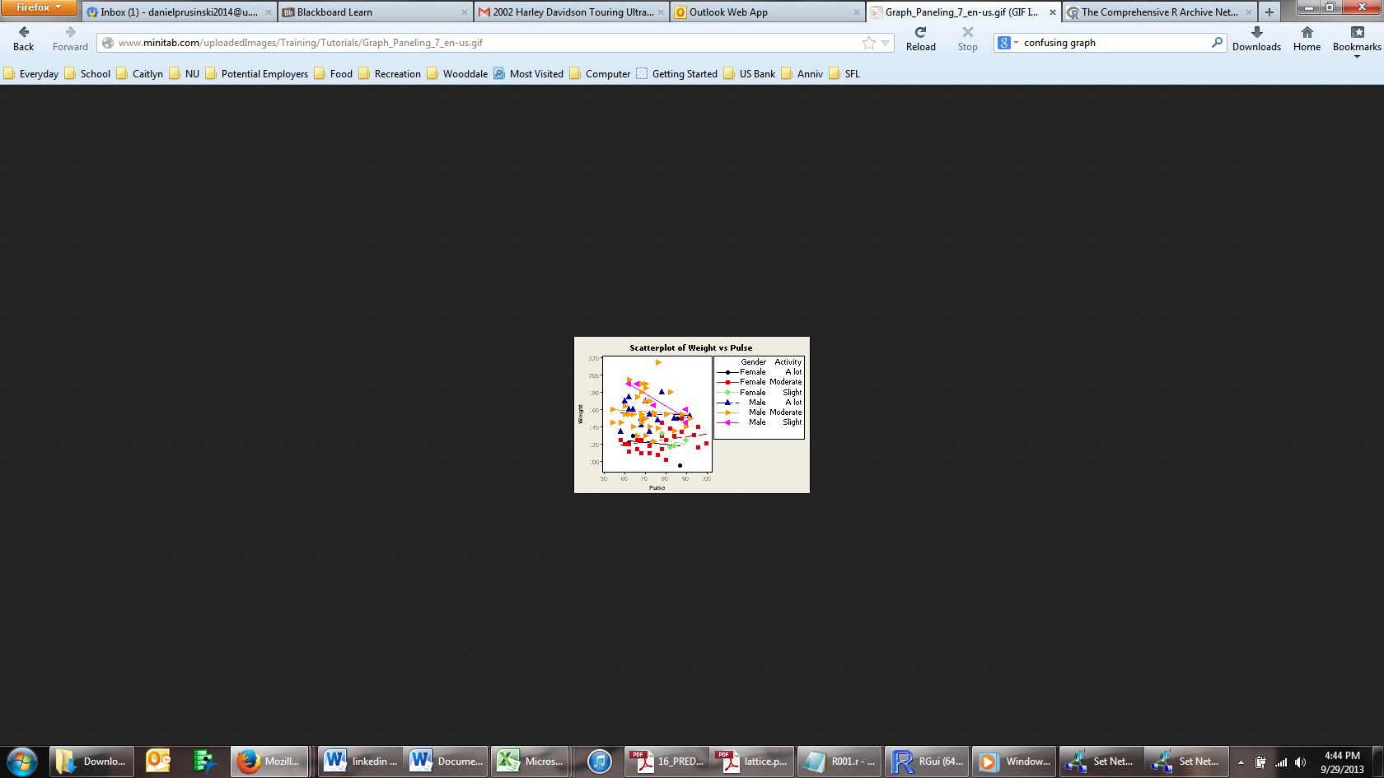The scatterplot to the left is confusing for the following reasons:

The density of the plots makes it very hard to discern any insights.

Some points have many plots, while the ‘female slight’ only has four discernable plots.

Two graphs could have easily conveyed the same information seeing that male and female plots are on different parts of the graph.

The legend is huge, which is taking away space for the graph.